**I2P:**

I2P URLs, known as **"eepsites"**, exist within the I2P network itself and cannot be accessed through the regular internet. These URLs usually end with .i2p and are hosted anonymously on the network.

**I2P Router Console**

After setting up I2P, open the **Router Console** by visiting:

http://127.0.0.1:7657

The console provides links to community resources and directories of I2P sites. Look for:

**"Jump Services"** or **"Eepsite directories"** that list popular .i2p sites.

Not all .i2p URLs are indexed in directories, so some sites might be shared privately. Always exercise caution when accessing unknown links within the I2P network.

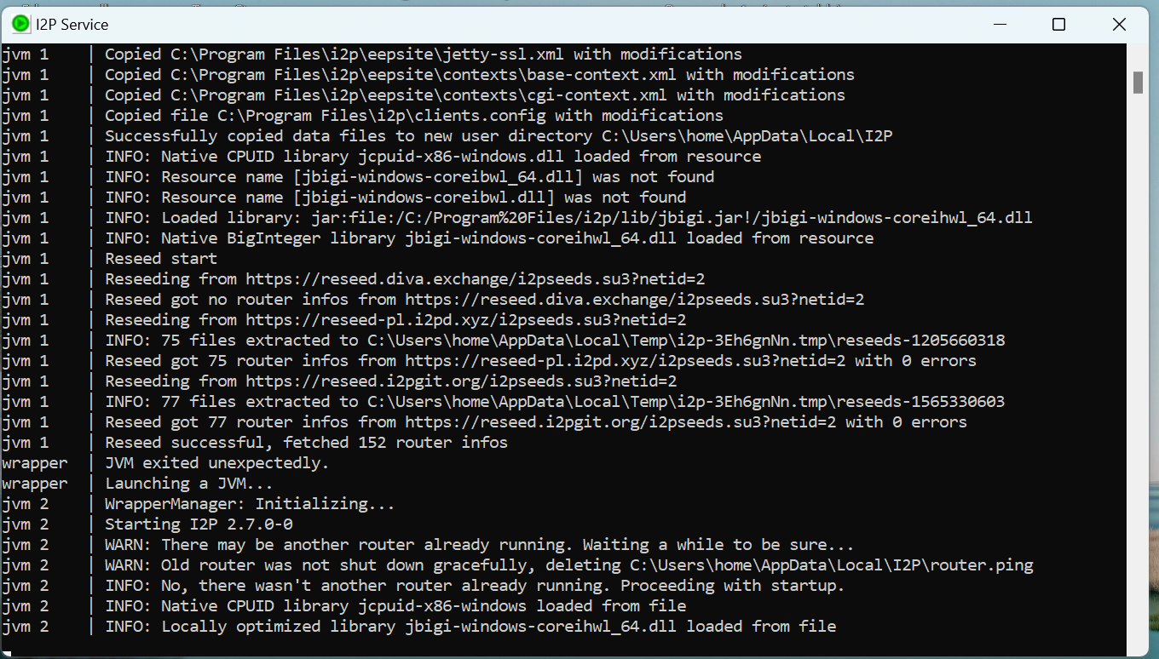

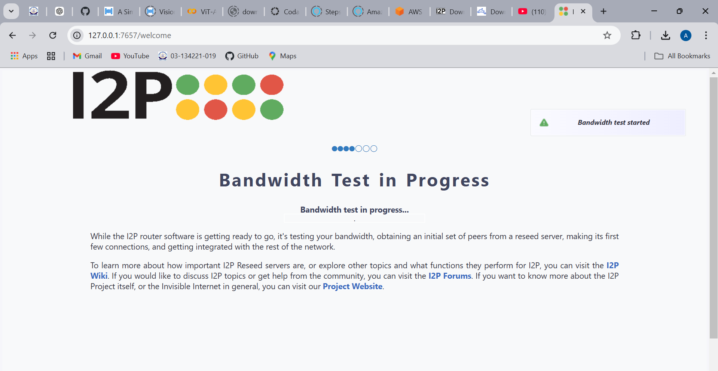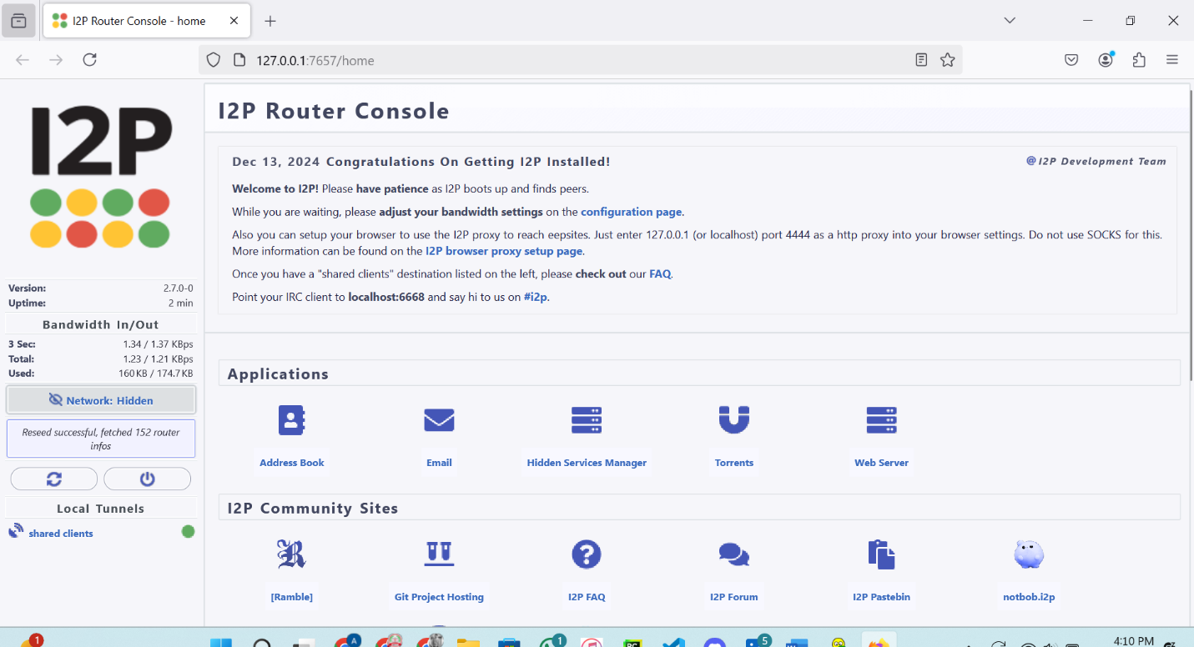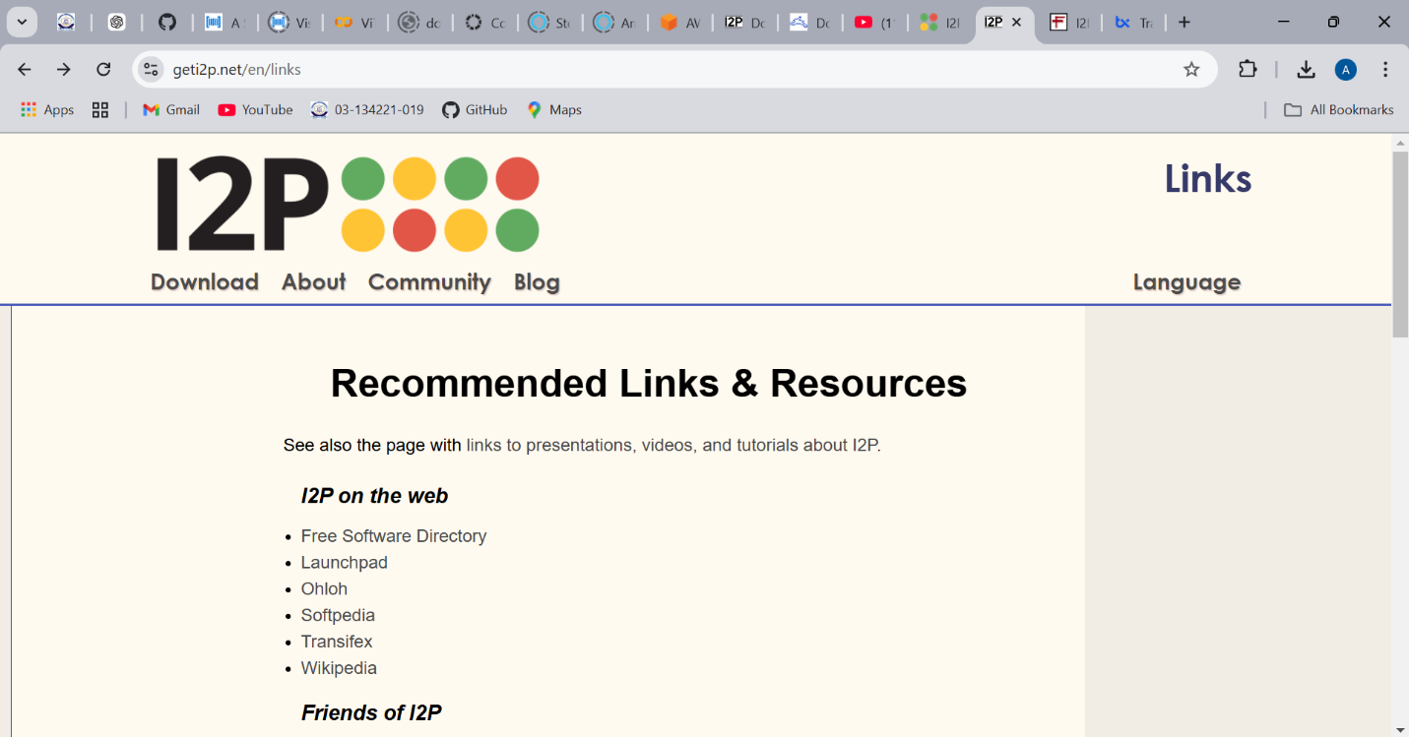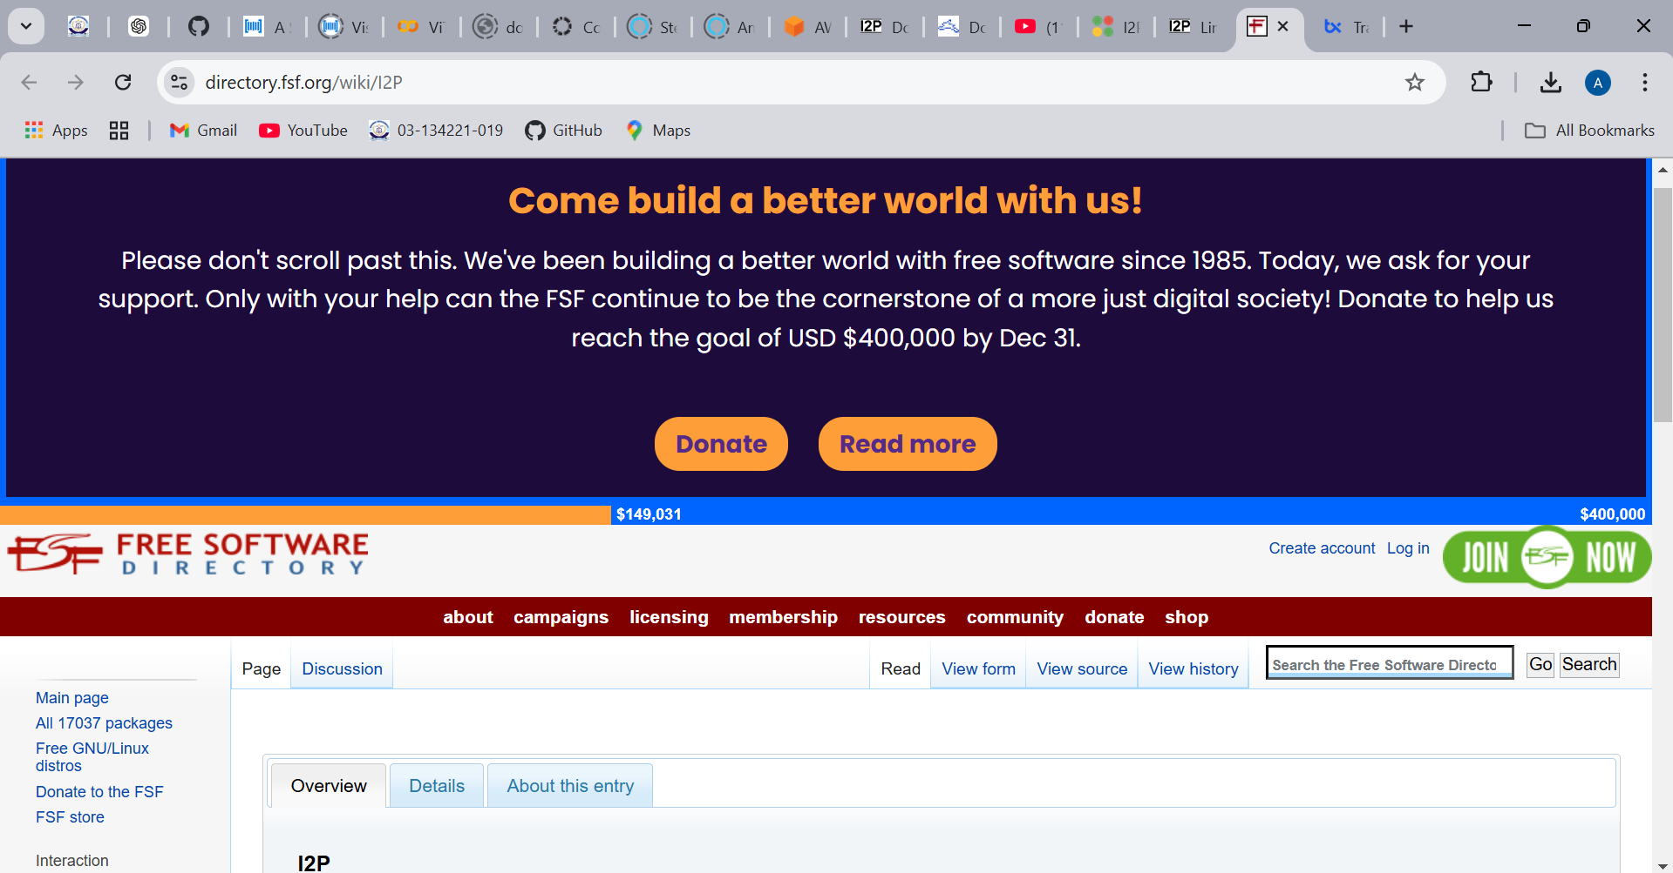

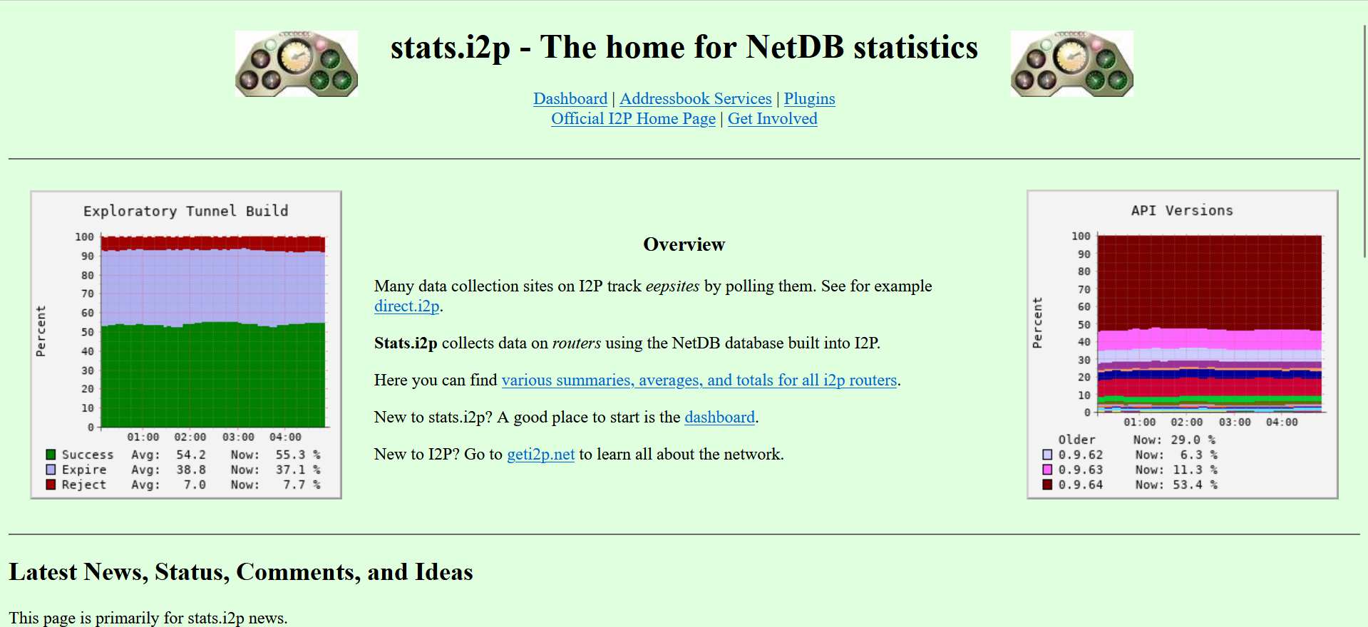

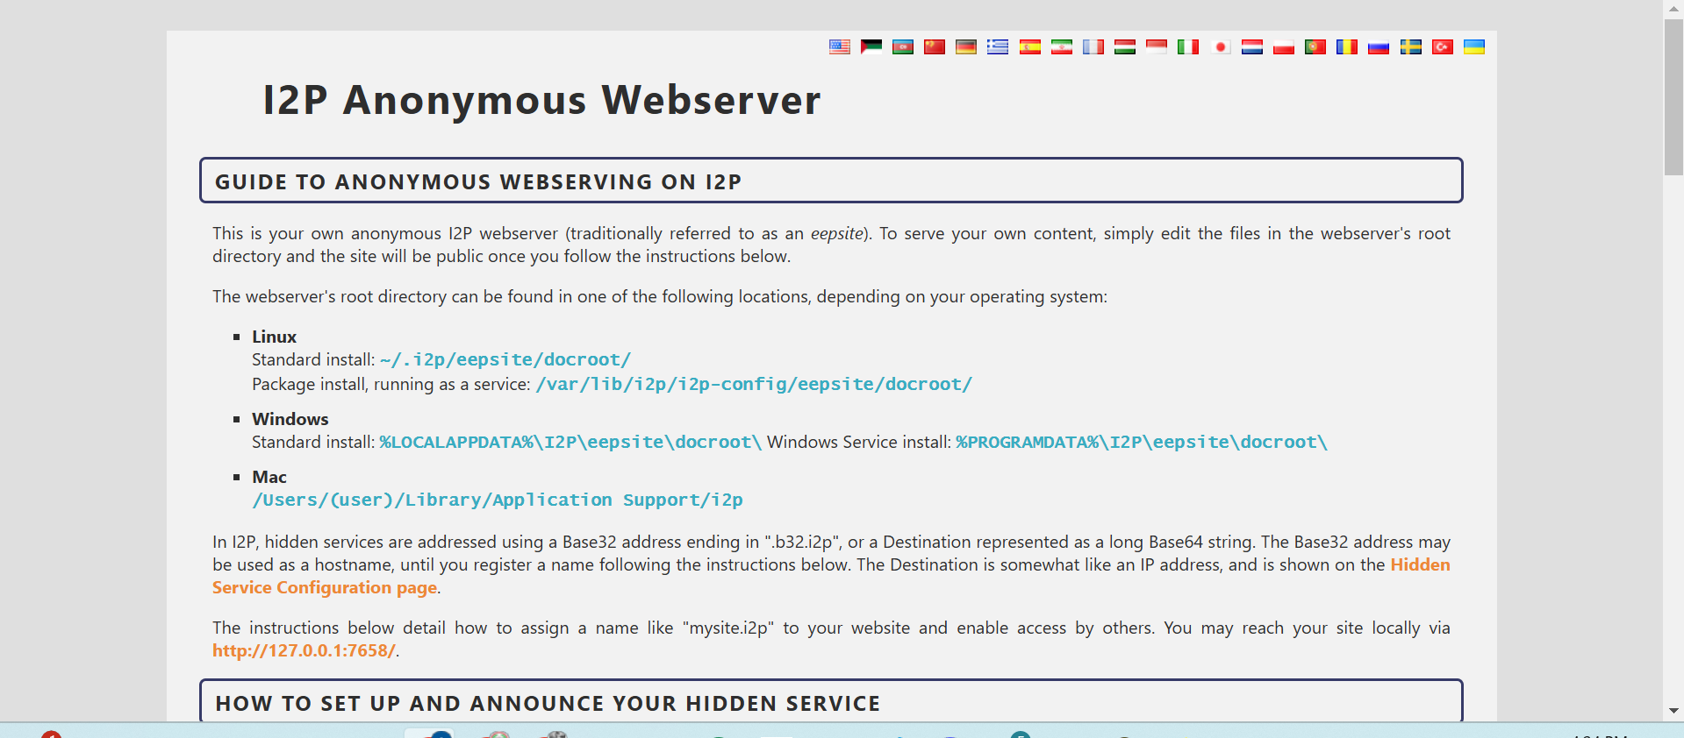

**FREENET:**





